**CACIE Tool** – ***Build Surface Flux (ca_build_surface_flux.py)***

**Version** **1.0**

**QA**: **TEST** or **NA** or **QA**

1. **Description and Purpose**

The Build Surface Flux tool reads a STOMP input file and extracts the grid card. The tool then reads a MODFLOW shapefile and extracts the corresponding grids that are within the STOMP grid coordinates. It then creates a ~surface flux card, mapping the STOMP grid into the MODFLOW grid.

1. **Functional Requirements**

The functional requirements of the Build Surface Flux tool are as follows:

FR-1: Parse arguments

FR-2: Extract STOMP Grid template (~Grid Card)

FR-3: Build x index values based on input file STOMP Grid template

FR-4: Build y index values based on input file STOMP Grid template

FR-5: Find all MODFLOW shapefile nodes that fall within the STOMP x-y boundaries (x1≤…<xn, y1≤…<yn)

FR-6: Find all applicable x-indices for each MODFLOW shapefile grid from FR-5

FR-7: Find all applicable y-indices for each MODFLOW shapefile grid from FR-5

FR-8: Write to surface flux card text file: for each MODFLOW grid from FR-5, summarize the relevant STOMP coordinate indices for each contaminant.

1. **Software Requirements Specifications**

The following are the software requirements for the Build Surface Flux tool with regards to programming language and versioning and the associated dependencies on libraries and/or modules.

* Python 3.6
* Libraries:  
  pyshp  
  shapefile  
  datetime  
  os  
  argparse  
  logging  
  itemgetter from operator

1. **Software Design Description**

The following is a brief description of required arguments and inputs and the output generated by the Build Surface Flux tool.

* Arguments:  
  contaminants   
  MODFLOW shapefile to use (input file: “.shp”)  
  STOMP input file to get grid card from (input file: “input”)  
  model name   
  output filename (output file: “.txt”)
* .sh file: runner_run_ca-surf_rad1.sh
* python [directory path]/pylib/runner/runner.py “python” “[directory path]/ca-surf/ca_build_surface_flux.py -c C-14 Cl-36 H-3 I-129 Np-237 Re-187 Sr-90 Tc-99 -shp "[directory path]/grid_attempt1.shp" -i "../ss/input" -s ModelName -o "./rad1_surface_flux.txt"”
* Basic usage: -c contaminates, -shp shape file to use, -i stomp input file to get grid card from, -s what model this is for, -o (optional) file name and directory to create the surface flux card
* .sh file: runner_run_ca-surf_rad2.sh
* python [directory path]/pylib/runner/runner.py “python” “[directory path]/ca-surf/ca_build_surface_flux.py -c U-232 U-233 U-234 U-235 U-236 U-238 Th-230 Ra-226 -shp "[directory path]/ca-surf/grid_attempt1/grid_attempt1.shp" -i "../ss/input" -s ModelName -o "./rad2_surface_flux.txt"”
* Basic usage: -c contaminates, -shp shape file to use, -i stomp input file to get grid card from, -s what model this is for, -o (optional) file name and directory to create the surface flux card

Code walkthrough was performed by Sara Lindberg on 06/11/2019. A limited number of editorial comments were made but none of the comments or their resolution impacted the functionality of the tool itself. A summary and resolution of the comments is presented in Appendix A, Table A-1.

1. **Requirements Traceability Matrix**

Table 1 presents the requirements traceability matrix for the Build Surface Flux tool.

|  |  |  |
| --- | --- | --- |
| **Table 1. Build Surface Flux Tool Requirements Traceability Matrix** | | |
| **Functional Requirement** | **Acceptance Test** | **Test Case** |
| QA Level | IT-1 | Installation Test |
| FR-1 | ATC-1 | Check log file “input data” values against arguments |
| FR-2 | ATC-2 | Check the following in log file:   * “stomp grid size,” * stomp grid x,” “stomp grid y,” and * “stomp grid k” values   against STOMP input file “Grid Card” values |
| FR-3 | ATC-3 | Check log file “stomp grid i” values against STOMP input file |
| FR-4 | ATC-4 | Check log file “stomp grid j” values against STOMP input file |
| FR-5 | ATC-5 | Check log file “shape_file_grids” values against STOMP x-y boundaries (x1≤…<xn, y1≤…<yn) |
| FR-6 | ATC-6 | Check contaminants and x-indices for one node in rad[]_surface_flux.txt |
| FR-7 | ATC-7 | Check contaminants and y-indices for one node rad[]_surface_flux.txt |
| FR-8 | ATC-8 | Check rad[]_surface_flux.txt “grid” values against log file “node” values |

1. **Test Plan and Cases**

The test plan and results for the Build Surface Flux tool is as follows.

| **Table 2. Build Surface Flux Tool Test Plan** | | |
| --- | --- | --- |
| **TEST ID** | **Test Case** | **Test Result  (Pass/Fail)** |
| Note [Testing_Directory] in acceptance test report | | |
| IT-1 | Installation Test |  |
| Navigate to [Testing_Directory]\ca-surf-test on a Linux platform | | |
| Invoke Build Surface Flux tool by entering the following entering the following:  ./ca-surf_rad1_run_ATC-1thru8.sh | | |
| Print out the following files:   * [Testing_Directory]\/ca-surf-test/log/error_modify_cards_log_yyymmdd.txt * [Testing_Directory]\/ca-surf-test \rad[]_surface_flux.txt * [Testing_Directory]\/ca-surf-test\ ca-surf_rad1_run_ATC-1thru8.sh * ([Testing_Directory]\ca-surf-test\ss\input | | |
| Compare generated output files (./ca-surf-test/log/error_modify_cards_log_yyymmdd.txt and rad[]_surface_flux.txt) against ca-surf_rad1_run_ATC-1thru8.sh and STOMP input file ([Testing_Directory]\ca-surf-test\ss\input) as follows: | | |
| ATC-1 | Check log file “input data” values (see Appendix A Attachment A-1) against arguments in [Testing_Directory]\ca-surf-test\ ca-surf_rad1_run_ATC-1thru8.sh (see Appendix A Attachment A-2) |  |
| ATC-2 | Check the following values in log file:   * “stomp grid size,” * stomp grid x,” “stomp grid y,” and * “stomp grid k” values   against STOMP input file “Grid Card” values (see Appendix A Attachment A-3) |  |
| ATC-3 | Check log file “stomp grid i” values against STOMP input file |  |
| ATC-4 | Check log file “stomp grid j” values against STOMP input file |  |
| ATC-5 | Check log file “shape_file_grids” values against STOMP x-y boundaries (x1≤…<xn, y1≤…<yn) |  |
| ATC-6 | Check contaminants and x-indices for one node in check rad[]_surface_flux.txt (see Appendix A Attachment A-4) |  |
| ATC-7 | Check contaminants and y-indices for one node in check rad[]_surface_flux.txt |  |
| ATC-8 | Check rad[]_surface_flux.txt nodes against log file nodes |  |

See appendix for the corresponding acceptance test case test logs as noted in the test case descriptions.

1. **Acceptance Test Report**

Acceptance testing was performed in accordance with the test plan documented in Section 6. The acceptance testing was performed in the following directory:

\\olive\backups\CAVE\sara-sandbox\ToolsTesting\ca-surf_atc_testing_model

The Build Surface Flux tool met the functional requirements as documented in Section 2. Verification of the tool’s functionality is documented in the test logs included in Appendix A. There were no incidents requiring resolution and accordingly, there are no unresolved incidents.

1. **User Guide**

The Build Surface Flux tool will be invoked using the Tool Runner tool using a shell script as defined in Section 4. The following defines the arguments specific to the Build Surface Flux tool.

Command line Arguments:

-s: Name of Sim Model, defaults to “Unknown”

-i: location and name of the input file with the ~grid card to be used. Defaults to the sim template

-shp: shapefile with the ground water grid to be used

-c: Constituents used in this model

-n: Name of person running the script

-o: Directory and name of output file default: output/{model}/{date}/_solute_flux_card.txt

-csv: location to create csv file to check shapefile grid to stomp grid conversion. default: csv/{model}/{date}/{model}_grid_conversion.csv

-b: turn on boundaries for solute flux and Aqueous Volumetric:

* example: BNS will turn on bottom, North, and South.
* example 2(default): B will turn on bottom only

**Appendix A**

**Code Review Summary   
and   
Acceptance Testing Logs**

| **Table A-1. Build Surface Flux Tool Code Review Summary** | | | |
| --- | --- | --- | --- |
| **Code Line** | **Comment** | **Function Impact** | **Resolution** |
| 49-64 | Function “validate_contaminates is not called in main body of code | No impact to functional requirements | Function is obsolete due to changes in functional requirements; code commented out |
| 95,99, 101,103 | As written code truncates last character in string; for lines 99,101,103: end up with an empty string member in list (example: stomp grid y = [‘573100’, ‘m’, ‘60@10, ‘’] | No impact to functional requirements but suggest the following: grid.append(l.split(‘,’)) | By design—no change to code |
| 220 | Is this list of contaminates still needed? | No impact to functional requirements | List variable is still required but elements do not need to be defined; list variable retained but list elements deleted |
| 393 | Variable y_nodes never referenced | No impact to functional requirements | Variable obsolete; code deleted |
| 394 | Variable x_nodes never referenced | No impact to functional requirements | Variable obsolete; code deleted |

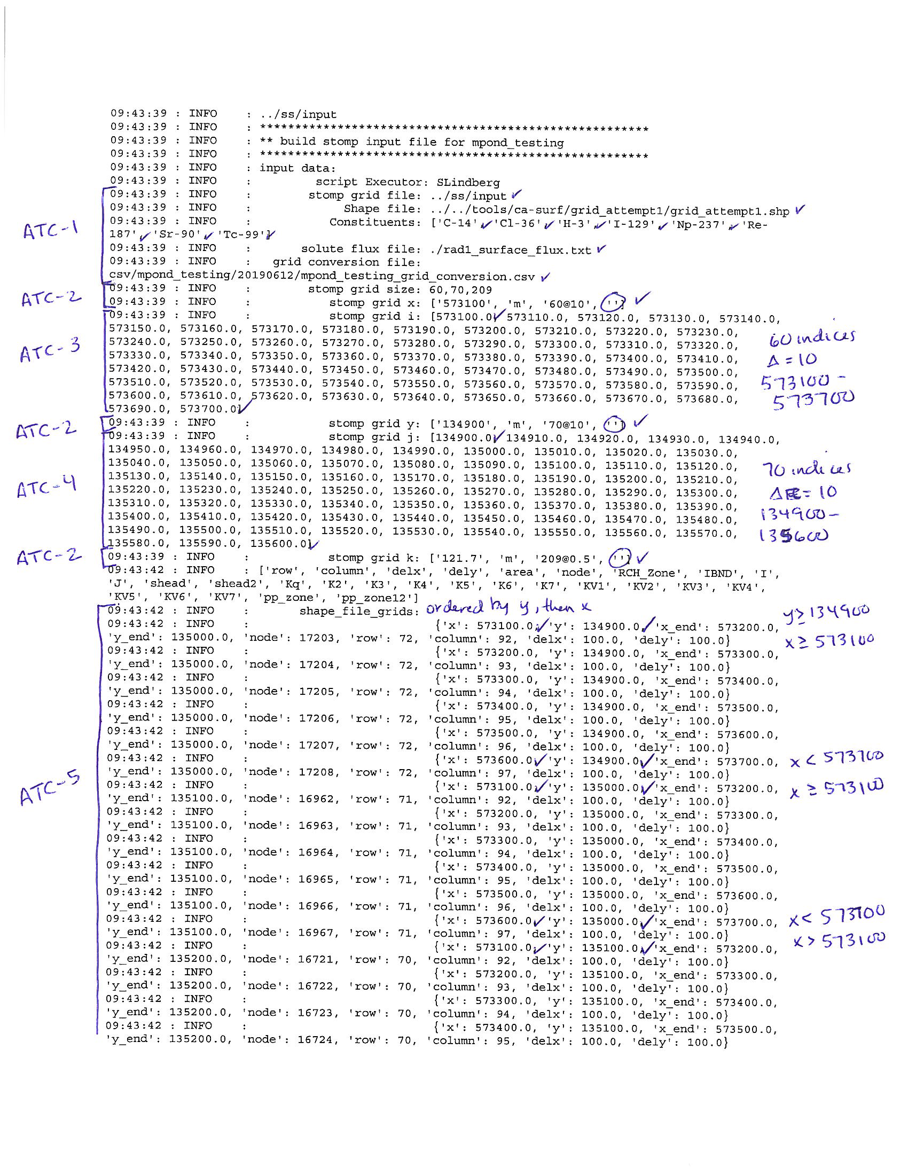

**Attachment A-1. Build Surface Flux Tool Log File (page 1 of 2)**



**Attachment A-1. Build Surface Flux Tool Log File (page 2 of 2)**



**Attachment A-2. STOMP Input File (page 1 of 1)**



**Attachment A-3. Output File Generated by the Build Surface Flux Tool  
Rad1_surface_flux.txt (page 1 of 7)**



**Attachment A-3. Output File Generated by the Build Surface Flux Tool  
Rad1_surface_flux.txt (page 2 of 7)**



**Attachment A-3. Output File Generated by the Build Surface Flux Tool  
Rad1_surface_flux.txt (page 3 of 7)**



**Attachment A-3. Output File Generated by the Build Surface Flux Tool  
Rad1_surface_flux.txt (page 4 of 7)**



**Attachment A-3. Output File Generated by the Build Surface Flux Tool  
Rad1_surface_flux.txt (page 5 of 7)**



**Attachment A-3. Output File Generated by the Build Surface Flux Tool  
Rad1_surface_flux.txt (page 6 of 7)**



**Attachment A-3. Output File Generated by the Build Surface Flux Tool  
Rad1_surface_flux.txt (page 7 of 7)**